Some information about your “new” old wall phone.

Thank you for your purchase. I came up with this information sheet to cover some very common problems and questions I get. If you don’t see information that you need here, feel free to contact me.

I only sell modular wall phones, this is for the convenience of my customers who may or may not be handy with tools and installing a hardwired phone. The phones I sell all have a standard modular back and are designed to just snap into place on a standard wall jack. Different models of phones that use this modular wall jack may look different on the back, but the one thing they will have in common is the “slide jack” in the center. You will see above and below that slide jack two T-shaped slots. The jack and these two slots match up with components on the wall jack. When installing, make sure the two studs are firmly in the slots and then pull down slightly on the phone. This will lock the phone into place.

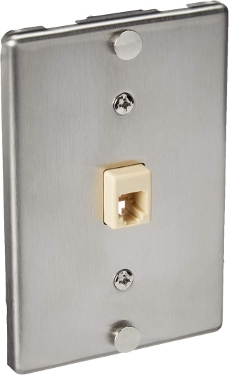At left is a picture of what your wall jack should look like. The materials may be different, but generally you will see that the female socket in the middle is slightly elevated and there are the locking studs at the top and bottom. If you have something else there, it is easily replaceable, you can pick them up cheap on Amazon. The one pictured is a Leviton C0256-SS and is a very good quality. This kind of jack is called a “flush mount” jack. It’s meant to go on over an existing junction box, much like a light switch cover.

If you are planning on putting your phone where there isn’t currently a jack, then you’ll need a “surface mount” jack, which, as the name implies, mounts to the surface of the wall and not over a box. To simplify this, I have a wall phone mounting kit. With the kit, you get everything you need with installation instructions. You can find this for sale on my website at www.ericofon.com/catalog/parts/jacks.htm

Common Issues

No Dial tone:

-The phone isn’t properly attached to the plate. Make sure the studs and slots are lined up when mounting. If one slot engages and the other one doesn’t, the phone will seem to be in place, but it won’t be in tightly enough for the jacks to make contact.

-Is the jack live? Try plugging in a corded phone into the jack, make sure you hear a dial tone. You can also try calling the phone from another number to see if it rings.

Rotary phones only: Rings and you can talk, but won’t dial out. You likely have digital phone service that does not accept rotary dialing. You’ll need a digital conversion to fix this. Contact me for more information.